Approved: / /

TOWN OF WINCHENDON

Conservation Commission 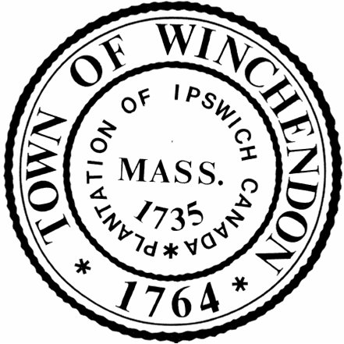 Telephone (978)-297-5402
Regular Meeting/Public Hearing
March 10th, 2022
Town Hall 2nd Floor Auditorium
109 Front Street, Winchendon, MA 01475

PRESENT: Kyle Bradley (present via phone), Lionel Cloutier, Ken Wante
Matt Morrow, Conservation Agent
ABSENT: David Whitaker, Melissa Blanchard

MATERIALS: Agenda & Notice of Meeting: March 10th, 2022, 2/10/22 Minutes

CALL TO ORDER: K. Bradley called the meeting to order at 6:00PM

ANNOUNCEMENTS: None.

MINUTES: February 10th, 2022

K. Wante motioned to approve the February 10th, 2022 minutes, 2nd by L. Cloutier. All voted aye.

HEARINGS:
6:05PM Request for Determination of Applicability (RDA)
Applicant: Al Sousa
Project Address: 16 Winter Place; Assessor’s Map 5A3, Parcel 51
Project Description: Addition of 2nd floor to home

Applicant was not present. M. Morrow reviewed the plan and presented via computer. The members of the board did not have any questions or concerns.

K. Wante motioned for a negative determination, 2nd by L. Cloutier. All voted aye.

West Street Solar 1-Set site visit date/time:
The members agreed to wait until April to do a site visit. A site visit was planned for Sunday April 10th, 2022 at 1:00PM.

Community Preservation Act (CPA)- Discussion: L. Cloutier will be a regular member at large for the CPA board.

NEW BUSINESS:
119 Laurel Street- Certificate of Compliance
K. Wante motioned to issue a Certificate of Compliance at 119 Laurel St, 2nd by L. Cloutier. All voted aye.
4 Summer Drive: M. Morrow explained this is a town project putting in a development. The town needs to do some soil remediation, so it was suggested they file a RDA for the soil removal to have it on record. and after file a NOI for the redevelopment.

K. Wante made a motion to adjourn, 2nd by L. Cloutier and all voted aye.

ADJOURNMENT: 6:16PM

Respectfully submitted,
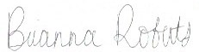
Brianna Roberts, Conservation Commission Recording Secretary

____________________________________ ____________________________________
Kyle Bradley, Chairman David Whitaker, Vice-Chairman

____________________________________ ____________________________________
Melissa Blanchard Lionel Cloutier

____________________________________
Ken Wante

