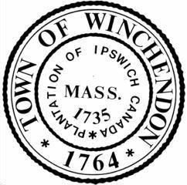
Report of the Town Manager
June 27th, 2022

Financial Updates-
- CARES funding, which was the first Federal Stimulus Package in response to the COVID 19 Pandemic, has officially been closed out for Winchendon.
- Year end procedures continue, with final transfers to occur before July 15th.

Personnel Updates-
- Interviews were held today for the vacant Treasurer’s position. It is our goal to have that role filled prior to the end of July.
- A posting will be advertised internally for the Part-Time Recreation Coordinator Role.
- We are continuing our review of the Planning and Development Director role and will have an update at the next meeting.

Project Updates-
- The WRA will be hosting a walkthrough of the Beech Street property on Monday, July 18th.
- Paving Season continues throughout town. Mellen Road was paved on Monday the 20th. We are working to use our funds as efficiently as possible. This includes efforts to push up our paving schedule to avoid increases in material costs for next fiscal year.

Miscellaneous Updates-
- Thank you to the Office and Planning & Development, The Recreation Committee, and all other departments and boards that contributed to the Food Truck Festival this weekend.

