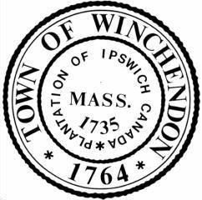
Report of the Town Manager
July 11th, 2022

Financial Updates-
- The Finance Committee will be meeting tomorrow to finalize year end Transfers.
- We are researching the process to receive funds from the National Opioid Settlement. An exact figure will be communicated to the board once determined.

Personnel Updates-
- A second round of interviews was held for the Treasurer position today.
- The Part-Time Recreation Coordinator position has been posted internally as of this afternoon.

Project Updates-
- A site walk was held at the Winchendon Community Park last week. This included the Town Manager, Architects, Project Managers, and Construction Firm to inspect the progress of the new Amphitheater.
- Russo Barr, the Architect for the Old Murdock, will be in town in the coming weeks to kick off the design process for the much needed repairs at the Senior Center.
- Work will begin on the Town Hall Cupola starting no later than early September.
- Central Street Construction was on pause for the 4th of July holiday, but has commenced this week. It is still on track for substantial completion in October.
- The curbing and most of the sidewalks are in place on Railroad, with some minor remaining pieces to occur over through July.
- The skylight in the Beals Memorial Library has been removed for repair offsite. We expect this to be reinstalled before the fall.

Miscellaneous Updates-
- I toured the Riverside Cemetery last week with our DPW Director and Cemetery Foreman. We will be coming forward with a plan shortly to expand the existing footprint as space is currently running low. This will also include a review of current prices.

