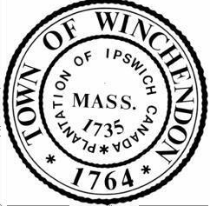

Report of the Town Manager

April 11, 2022

- Financial Updates-
  - The Audit Committee has been contacted and will be establishing a kick-off meeting shortly.
  - We are in the process of reviewing Snow & Ice deficits for FY22 and will be working to identify a funding source to transfer from as numbers settle for the year.

Personnel Updates-
  - No personnel updates at this time.

Project Updates-
  - We continue to monitor work on Central Street. We will coordinate with residents and business owners as work progresses.
  - RFQ’s for Designer Services for the Old Murdock Restoration have been submitted. We received two proposals by the deadline, and are currently reviewing the documents with CBI Consulting.
  - Preliminary flagging took place over the weekend for the Winchendon Community Park Amphitheater. We are working with the contractor to put a schedule in place that will minimize the impact to citizen access to the park during construction.
  - The CDBD Grant process for Beech Street continues. We will be soliciting input from residents along that street, with a public input session to be announced in the coming weeks.
  - The TIP Request for Blair Square has been submitted. This will be a several years process. The TIP covers construction costs, however the Town will be responsible for funding the design process. To date this has been funded by a year end transfer from the Finance Committee and Board of Selectmen, and more recently ARPA. We will be submitting a request to the Robinson Broadhurst Foundation in the fall to get us through the last leg of design fees.
  - We are in the process of submitting Final Written Reports to the Robinson Broadhurst Foundation for outstanding projects in town. This is an annual process. The RBF will be in town in late April for a final review of request for FY22.

Miscellaneous Updates –
  - The CPAEC met last Monday the 4th, with significant progress made. They have opted to meet biweekly, with the goal to deliver a determination to the BoS by August.
  - I toured our Wastewater Treatment Facility to get a better understanding of the operations. Should any board member like to walk the plant in the future I will coordinate a time.

