ARTICLE 9 - SIGNS

- Purpose
The purpose of this article is to provide property owners, residents, and occupants an opportunity for effective identification of goods and services provided on the premises subject to reasonable and appropriate conditions in all zoning districts, and to maintain and enhance the quality of the Town’s appearance by:

- Controlling the size, location and design of temporary and permanent signs so that the appearance of such signs will reduce sign clutter, be aesthetically harmonious with their surroundings, and will enhance the overall appearance of the built environment;
- Ensuring that signs are located and designed to maintain a safe and orderly pedestrian and vehicular environment;
- Reducing potentially hazardous conflicts between commercial or identification signs and traffic control devices and signs;
- Providing a pleasing overall appearance, protect historic context, and enhance community character which is essential to the economic viability of the Town;
- Protecting property values and the general public from damage or injury caused by, or partially attributable to the distractions and obstructions which result from improperly designed or situated signs;
- Allowing signs appropriate to the planned character of each zoning district within the Town; and
- Promoting the public safety, welfare, convenience, and enjoyment of the residents of Winchendon.

- Applicability
- Nothing contained in this article shall be construed as the content-based regulation of sign messages prohibited by the federal or state constitution, statues, or court decisions.
- Nothing contained in this section shall be construed to conflict with M.G.L. Chapter 85, Section 8 & 9 or M.G.L. Chapter 93, Sections 29 through 33, as amended.
- All signs placed on public property or within a public right-of-way are subject to approval by the Town Manager or his/her designee according to provisions set forth in the Town Manager’s Policies and Procedures.

- Special Permit Review
- Review Criteria. Signs permitted by Special Permit require supplemental review and must meet certain performance standards for the issuance of a sign permit. The Planning Board shall serve as the Special Permit Granting Authority (SPGA) for the purpose of reviewing Special Permit applications for signs under this section. In its discretion to approve or deny a special permit to authorize a sign, the SPGA shall consider the following criteria:
- Design of the sign as an effective means of communication.
- Compatibility with the visual character of the surrounding area.
- Appropriate sizing for the location.
- The potential for adverse effects on nearby properties and pedestrian and traffic safety.

- Concurrent Applications. Review of Special Permit applications that appear before the Planning Board for projects additionally requiring site plan review may appear concurrently before the board in accordance with the submission and procedure requirements for such applications.

- Sign Maintenance, Abandonment and Removal
- All signs, including nonconforming signs, together with any supports, braces, anchors, and other supporting hardware, must be maintained in good condition or state of equivalent quality to which was approved or required by the Town. If the Building Inspector is of the opinion that a sign is not secure, safe or in good state of repair, it shall give written notice of this fact to the person responsible for the maintenance of the sign. If the defect in the sign is not corrected within the time permitted, the Building Inspector may revoke the permit to maintain the sign and may remove the sign and keep possession of same until the owner pays the cost of removal.
- When an existing sign is removed, replaced, or repaired, all supports, braces, anchors, and other supporting hardware that is no longer required must be removed, and any surfaces baring evidence of attachment must be repaired.
- An on-premises sign advertising an activity, business, service, or product must be removed or the sign face replaced with a blank face within 60 days of the activity, business, or service promoted by the sign being discontinued on the premises where the sign is displayed.
- If the use is not reestablished or a new use is not established within two (2) years, then the entire sign structure and mounting hardware must be removed, unless the sign is one section of a larger sign structure advertising multiple activities, businesses, services, or products within a multi-unit building or business park.

- Maximum Building Signage and Sign Copy Area
- The maximum square footage of all signage for a building in the specified zoning district shall be the combined length of all building primary street frontage multiplied by two. This includes any combination of Permanent Principal Signs in accordance with the standards established in Figure 9.9.2 for individual sign types.
- For A-frame, awning/canopy, building mounted, freestanding, and projecting signs, the sign copy area shall be considered to include all lettering, wording, and accompanying designs and symbols, together with the background, whether open or enclosed, on which they are displayed, but not including any supporting framework and bracing that are incidental to the display itself. Only one side of a projecting sign shall be counted in computing the total square feet of signs on a sign frontage.
- For a sign painted upon or applied to a building, the sign copy area shall be considered to include all lettering, wording, and accompanying designs or symbols, together with any background of a different color than the natural color of the building.
- For a sign consisting of individual letters or symbols attached to or painted on a surface, building, canopy, awning, wall or window, the sign copy area shall be considered that of the smallest rectangle or other geometric shape that encompasses all the letters or symbols.

- Sign Illumination
Conforming signs may be illuminated according to the following standards:
- General. Illuminated signs indicating if a business is open must be turned off except during the hours of operation.
- External Illumination.
- An externally illuminated sign is characterized by the use of artificial light reflected off the surface of a sign.
- External light sources must be shielded so that they illuminate only the face of the sign and do not shine directly onto a public right-of-way or onto adjacent properties.
- Light fixtures that project from the facade of a building for externally illuminated signs are exempt from setback requirements but should be simple and unobtrusive in design and not obscure the sign content.
- Internal Illumination.
- An internally illuminated sign is characterized by the use of artificial light projecting through or from behind the surface of a sign.
- Channel letters may be internally lit or back-lit.
- Blade signs may be internally lit if the background is opaque or of a darker color than the message of the sign and the lettering is no more than 50% of the surface area of the sign.
- Exposed neon is only permitted for wall, blade, or windows signs.

- Backlit (i.e., Halo) Signs. Backlit Signs shall light lettering and logo and other related sign elements only, and lighting design shall be such that no excess light spill or glare results from the back lighting fixtures and/or source. The back lit sign shall not increase the measurable vertical light level at a point 20 feet distant from the Sign in any direction.
- Neon Signs. Neon signs are permitted by Special Permit as an alternative form of Wall, Blade, or Window sign subject to the review criteria of 9.3.1.

- Structures and Installation
- Support Elements. Supports and braces shall be designed as an integral part of the sign design and hidden from public view to the maximum extent practical.
- Electrical Service.
1. All electrical fixtures requiring new devices, circuits, conduits, raceways, or apparatus used to illuminate, move or project any sign shall be installed and maintained in accordance with the building code and the electrical code.
2. When electrical service is provided to freestanding signs, all such electrical service is required to be underground and concealed.
3. Conduits and other components of a sign illumination system shall be designed as an integral part of the sign design and hidden from public view to the maximum extent practical.
- Limitation on Attachments and Secondary Uses. All permitted sign structures and their associated landscape areas shall be kept free of supplemental attachments or secondary uses including, but not limited to, supplemental advertising signs not part of a permitted sign, light fixtures, newspaper racks, or trash containers. The use of sign structures and associated landscape areas as support structures for outdoor product display is prohibited.
- Durable Materials. All permanent signs permitted by this section shall be constructed of durable materials capable of withstanding continuous exposure to the elements and the conditions of an urban environment.

- Sign Placement at Intersections
For parcels located at the corner of two intersecting public or private streets including, but not limited to, driveways and service lanes associated with commercial and/or business sites, a clear view triangle shall be maintained. The triangle shall be the area formed by measuring a distance of 20 feet from the corner of the parcel along the lot lines and connecting the end points so as to establish a triangle on the area of the lot adjacent to the street and/or drive intersections. No sign, nor any part of a sign, other than a supporting pole or brace measuring 18 inches or less in width or diameter, shall be located between 3 feet and 10 feet above the grade within this sight triangle.

- Permitted Accessory and Principal Signs
- Permanent Accessory Signs Standards. Permanent Accessory Signs shall meet the standards set forth in Figure 9.9.1 and Figure 9.9.3.A through E below:
FIGURE 9.9.1 - PERMANENT ACCESSORY SIGNS
Sign Types | R80 | R40 | R10 | C1 | C2 | I | PD
A. A-Frame/Sidewalk Signs | SP | SP | SP | SP | SP | SP | P
B. Display Case | N | N | SP | P | P | P | P
C. Directory Signs and Nameplates | P | P | P | P | P | P | P
D. Other Accessory Signs | SP | SP | SP | SP | SP | SP | SP
P - Permitted by Right with Specifications under this Article
SP- Permitted by Special Permit from the Planning Board.
N – Not Permitted in the Zoning District

- Permanent Principal Signs Standards. Permanent Principal Signs shall meet the standards set forth in Figure 9.9.2 and Figure 9.9.4.A through K below:

FIGURE 9.9.2 - PERMANENT PRINCIPAL SIGNS¹
Sign Types | R80 | R40 | R10 | C1 | C2 | I | PD
A. Awning and Canopy Signs | SP | SP | SP | P | P | P | P
B. Bracket Signs | SP | SP | SP | P | P | P | P
C. Blade and Projecting Signs | SP | SP | SP | P | P | P | P
D. Freestanding and Yard Signs | SP | SP | SP | P | P | P | P
E. Vertical Blade/Banner Signs | SP | SP | SP | P | P | P | P
F. Marquee Signs | N | N | N | P | P | P | P
G. Suspended Signs | SP | SP | SP | P | P | P | P
H. Wall Mural | SP | SP | SP | SP | SP | SP | SP
I. Window Signs | SP | SP | SP | P | P | P | P
J. Monument Sign | P | P | P | P | P | P | SP
K. Wall Signs | SP | SP | SP | P | P | P | P
L. Other Principal Signs | SP | SP | SP | SP | SP | SP | SP
P - Permitted by Right with Specifications under this Article
SP- Permitted by Special Permit from the Planning Board.
N – Not Permitted in the Zoning District
1. All signs internally illuminated and/or including a static or dynamic message board shall require a special permit.

FIGURE 9.9.3 - PERMANENT ACCESSORY SIGN STANDARDS
A. A-FRAME AND SIDEWALK SIGNS
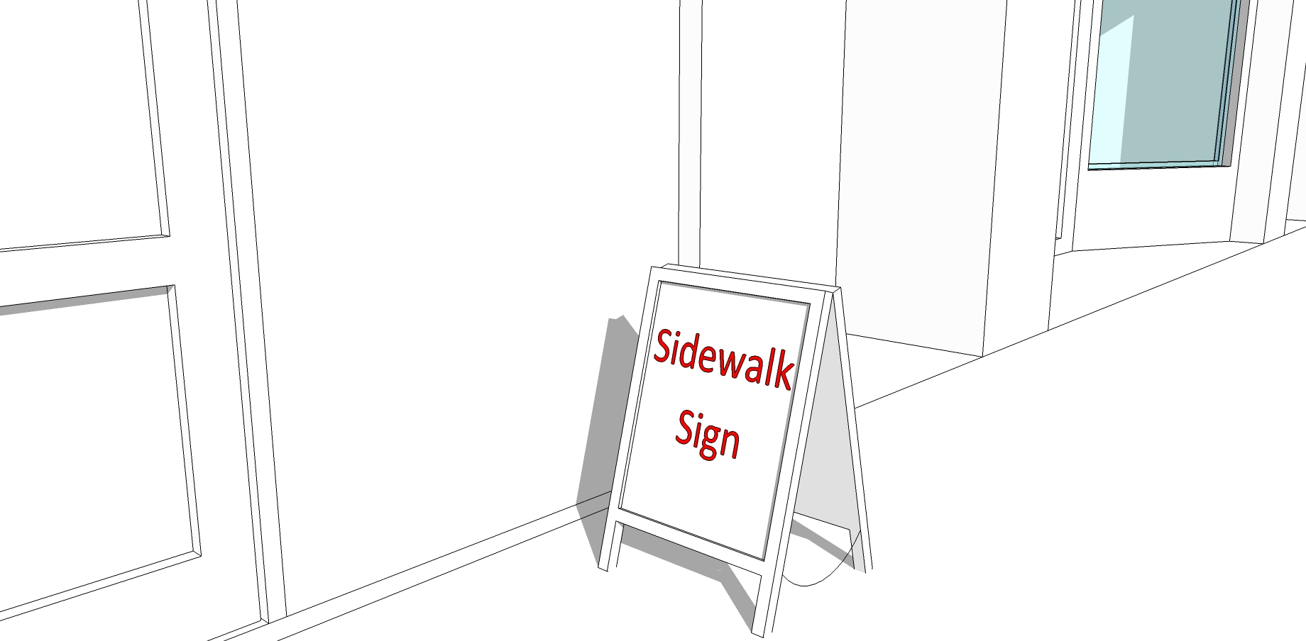
DEFINITION
A freestanding portable sign, not secured or attached to the ground or any building or structure, composed of a sign panel and supporting structure or one or more panels which form both the structure and sign face, and which is intended to be placed in a sidewalk or pedestrian way.
ZONING DISTRICTS ALLOWED
See Figure 9.9.1
SIGN SPECIFICATIONS
Number of Signs: | 1 per business unit maximum
Placement: | 8 feet from principal entrance maximum
Sign Height: | 4 feet maximum
Sign Width: | 2 feet maximum
Sign Area: | 8 square feet maximum per side.
Illumination: | Prohibited
OTHER FUNCTIONAL STANDARDS
One (1) Sidewalk sign is permitted per ground story tenant.
Sidewalk signs may be placed outdoors on site or on a public sidewalk during business hours and must be removed when the business is closed.
Sidewalks signs displayed on a public sidewalk are prohibited from interfering with pedestrian travel and shall leave clear an accessible walkway area of 4 feet minimum.
A sidewalk sign must be vertically oriented, with a height greater than its width and made of wood, metal, or slate (chalkboard).
A sidewalk sign is not permitted to be illuminated or contain any electronic components.
A sidewalk sign may not be placed outdoors when high winds, heavy rain, or heavy snow conditions are present. The Department Public Works may remove a sidewalk sign during snow removal operations and is not liable for damage to a sidewalk sign caused by snow removal operations.
Design/Construction: Constructed of a minimum ¾” high density exterior grade compressed wood or molded plastic of weight and durability to withstand wind gusts and maintained in a professional manner free from chipping paint, cracks, loss of letters, and other damages.

B. DISPLAY CASE
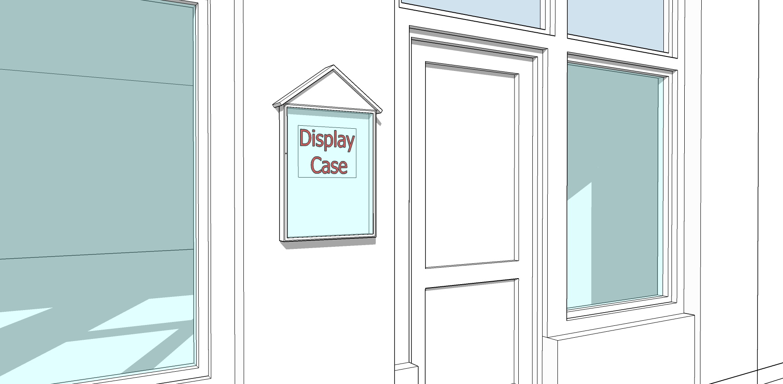
DEFINITION
A wall mounted, lockable, framed cabinet with a transparent window to display a changeable menu or list of event show times. Display cases are intended to be viewed at close range by pedestrians.
ZONING DISTRICTS ALLOWED
See Table Figure 9.9.1
SIGN SPECIFICATIONS
Number of Signs: | 1 per business unit.
Placement: | Shall be attached to the building wall on the primary or secondary frontage.
Sign Height: | Top of sign case shall not exceed 7 feet from grade.
Sign Width: | 4 feet maximum.
Sign Area: | 6 square feet maximum.
Illumination: | Non-illuminated or illuminated from inside the display case.
OTHER FUNCTIONAL STANDARDS
Outdoor display cases for theaters may be larger but shall not exceed 12 square feet.

C. DIRECTIONAL SIGNS
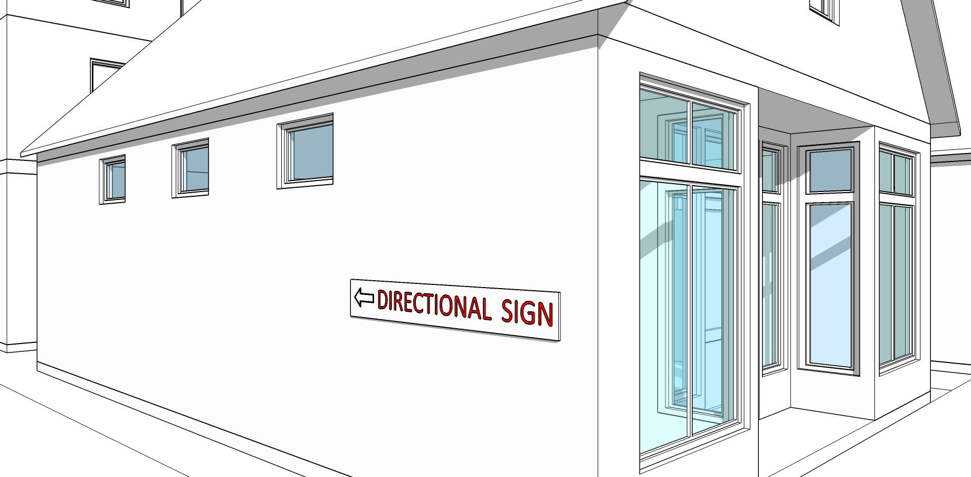
DEFINITION
A traffic, direction or informational on-premises sign located on private property at the curb cuts of an establishment giving direction or information as to entrance, exit and/or the like. Such signs may contain a logo or other information identifying the use of the premises so long as such information is for direction and point of reference and not for advertising purposes. Directional Signs may include information and directions necessary or convenient for persons accessing the property including signs marking entrances and exits, parking areas, one-way drives, rest rooms, pickup and delivery areas, loading zones and the like.
ZONING DISTRICTS ALLOWED
See Figure 9.9.1
SIGN SPECIFICATIONS
Number of Signs: | Unlimited, except that directional signs placed near driveway openings shall be limited to a max of one (1) at each location or access point per direction of travel. (e.g., One way ingress driveways are allowed one (1) sign, two-way driveways are permitted two (2) signs).
Placement: | Building-mounted directional signs must be affixed flat against the building wall, no higher than the 1st floor.
Sign Height: | Building Mounted: Max. 8 feet from grade
 | Freestanding: Max.3 feet from grade
Sign Area: | 3 square feet per sign face maximum
Illumination: | External illumination or non-illuminated only
OTHER FUNCTIONAL STANDARDS
None

D. DIRECTORY AND NAMEPLATE SIGNS
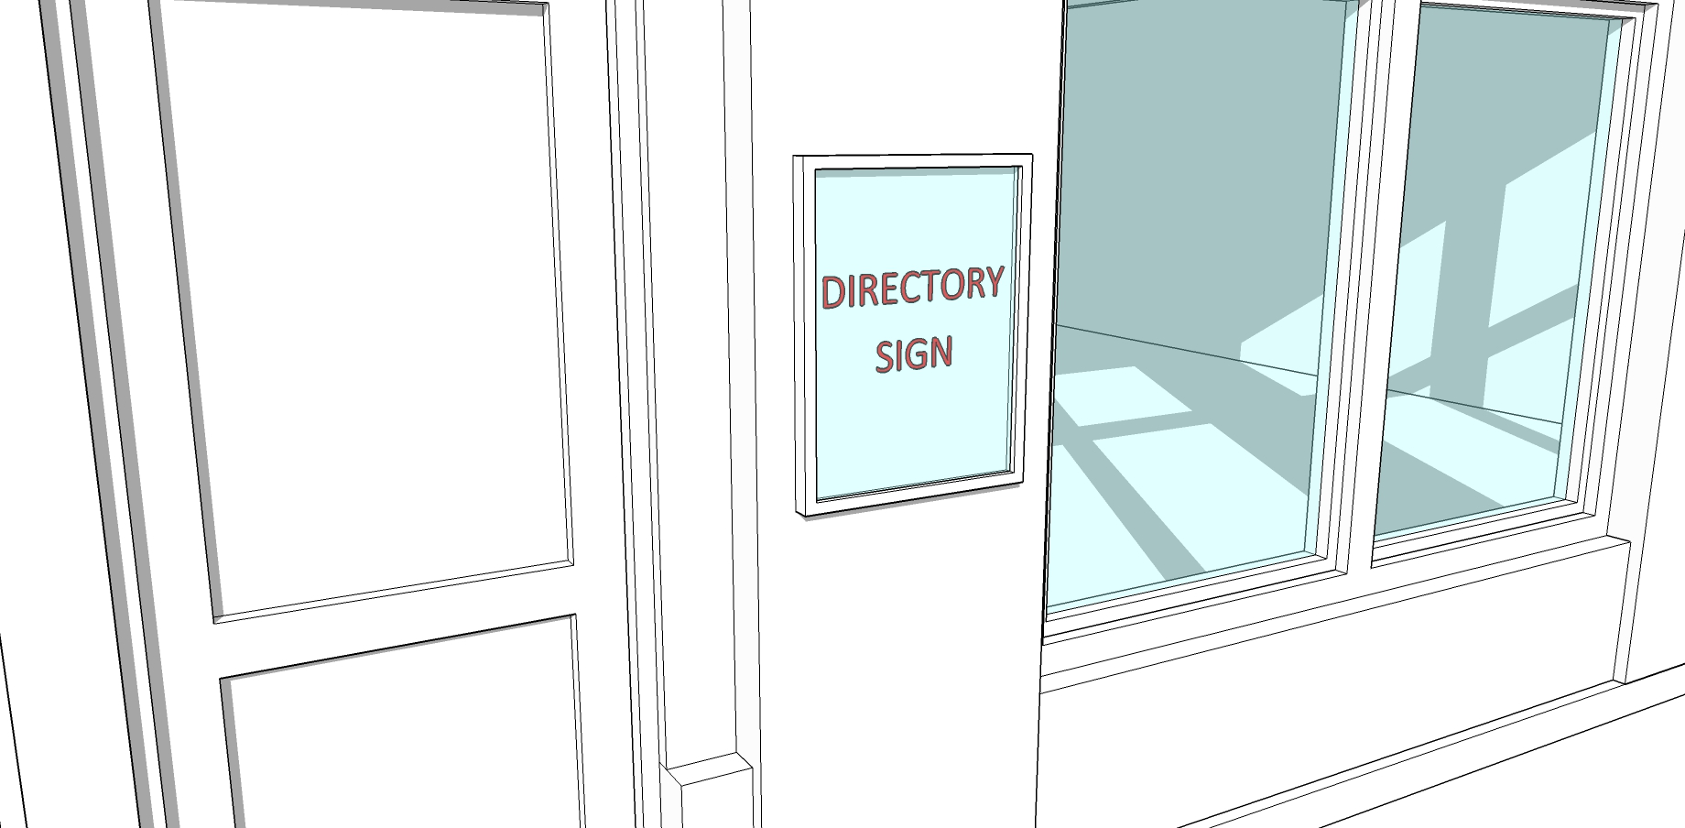
DEFINITION:
A single sign comprised of uniform individual signs placed or displayed in sequence and which may provide information in a list, roster, or directory format; generally, a sign listing the names and/or use, or location of more than one business, activity or professional office conducted within a building, group of buildings or commercial center.
ZONING DISTRICTS ALLOWED
See Figure 9.9.1
SIGN SPECIFICATIONS
Number of Signs: | 1 per address unless the street frontage of said institution exceeds one hundred (100) feet, then one (1) sign for each hundred (100) feet is allowed but in no event more than three (3) such signs per address.
Placement: | May be building mounted or mounted on a low-profile freestanding sign.
Sign Height: | Maximum 6 feet above grade.
Sign Area: | Maximum 16 square feet.
Illumination: | Non-illuminated, internally illuminated or indirectly illuminated
OTHER FUNCTIONAL STANDARDS
Directory signs may be placed at points nearest pedestrian entry to businesses within a multi-tenant building or development.
A nameplate shall only provide the name, address or logo of an owner, tenant, and/or the building to which it is affixed.
Nameplates shall consist of either a panel or individual characters applied to building walls within 4 feet of an entrance to the building.

FIGURE 9.9.4 - PERMANENT PRINCIPAL SIGN STANDARDS

A. AWNING AND CANOPY SIGNS
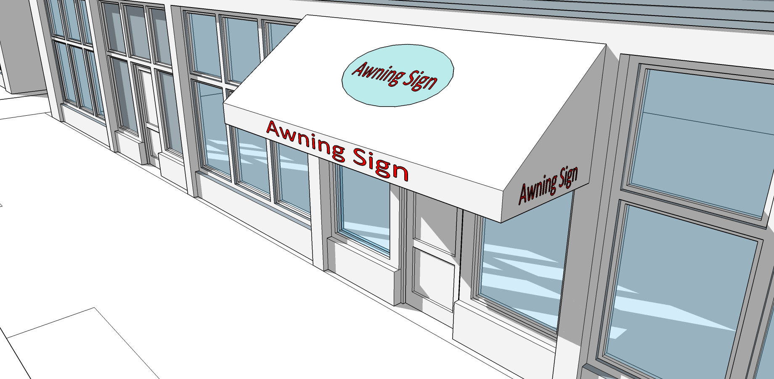
DEFINITION
A sign suspended from, attached to, supported from or forms part of a roof-like cover made of canvas or similar material which projects from the wall of a building for the purpose of shielding a doorway or window from the elements, not including a marquee. (An awning or canopy may or may not have signage.)
ZONING DISTRICTS ALLOWED
See Figure 9.9.2
SIGN SPECIFICATIONS
Number of Signs: | 1 per business unit.
Placement: | Top of awning may not extend above the bottom of the second story window of building.
Sign Height: | Minimum 8 feet clearance above sidewalk.
Sign Area: | The lesser of 1 square foot of sign area per linear foot of awning width; or 75% of valance or face; or 25% of the sloping plane.
Sign Lettering: | 5 inches minimum; 10" maximum on awning valance.
 | 18 inches maximum on sloping plane.
Illumination: | Canopies may be non-illuminated, internally illuminated or indirectly illuminated.
OTHER FUNCTIONAL STANDARDS

B. BRACKET SIGNS
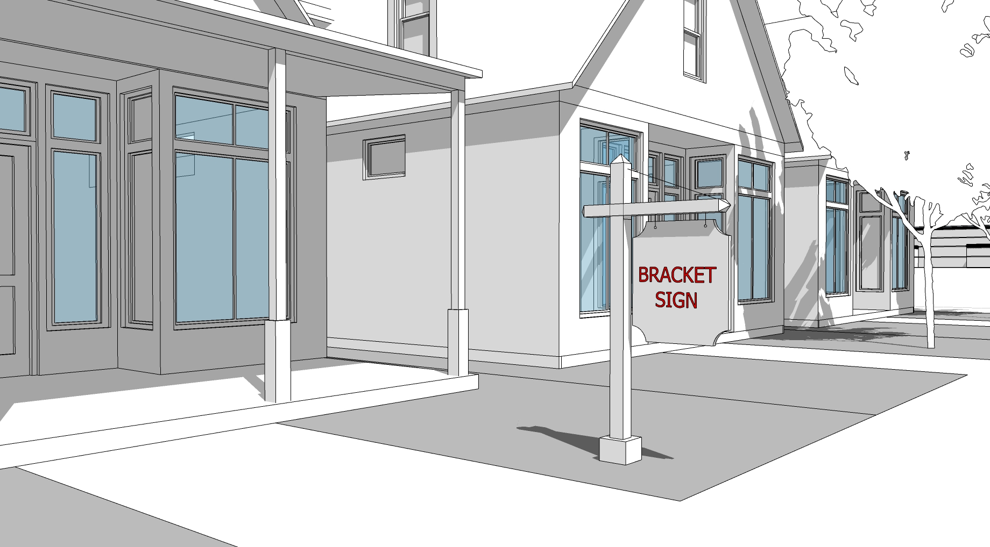
DEFINITION
A freestanding sign attached to the ground by one or more support structures that is not higher than 5 feet and hangs from a bracket or support.
ZONING DISTRICTS ALLOWED
See Figure 9.9.2
SIGN SPECIFICATIONS
Number of Signs: | 1 per street frontage
Placement: | In front of the building and setback a minimum of 3 feet from a public sidewalk.
Sign Area: | 9 Square Feet Maximum (Per Face).
Sign Structure Height: | 6 Feet Maximum.
Sign Area Height: | 3 Feet Maximum.
Sign Area Width: | 3 Feet Maximum.
Sign Structure Area Depth: | 6 Inches Maximum.
Illumination: | Externally illuminated (on structure or ground).
OTHER FUNCTIONAL STANDARDS
A bracket sign must be located at least 25 feet from another bracket sign.
The hanging bracket must be an integral part of the sign design.
A bracket sign can only be externally illuminated.
Neon is not permitted
Bracket side may be double sided

C. BLADE AND PROJECTING SIGNS
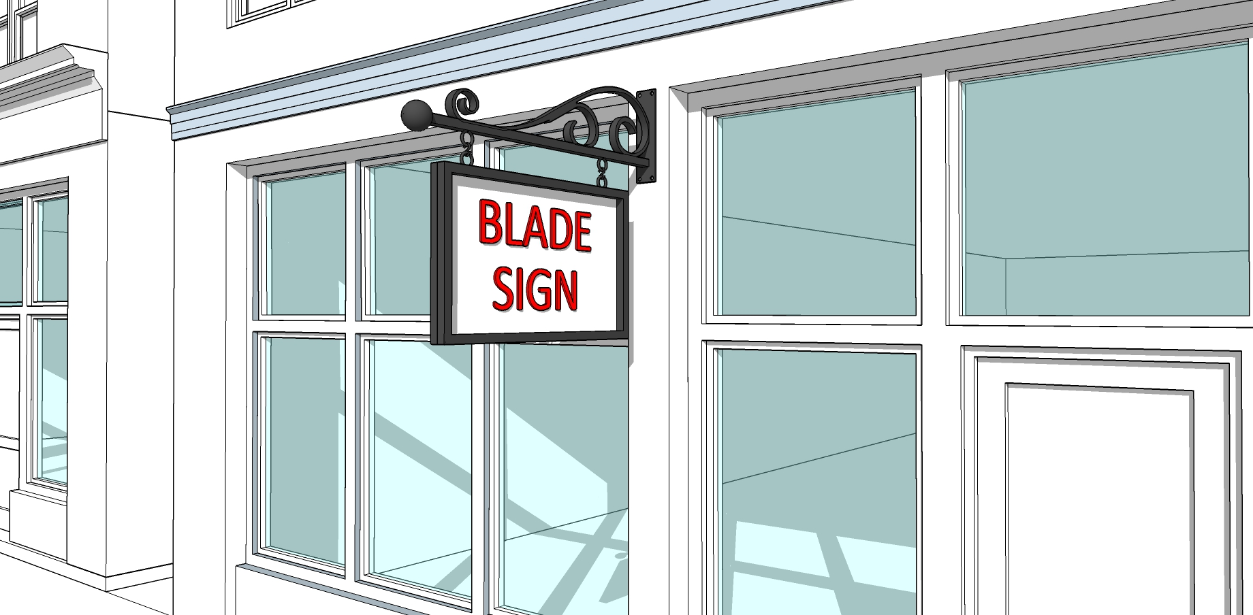
DEFINITION
A building mounted sign attached to, and extending from, a building or support beam in whole or in part which extends beyond said building.
ZONING DISTRICTS ALLOWED
See Figure 9.9.2
SIGN SPECIFICATIONS
Number of Signs: | 1 per business unit.
Placement: | Projecting signs may encroach into the public right-of-way but shall not be located within 4 feet to the closest curb line.
 | Sign shall be mounted a minimum of 6 inches away from the building.
Sign Height: | Minimum 8 feet from street grade to the bottom of the sign; 14 feet maximum measured from the street grade to the top of the light standard or supporting standards, whichever is greater.
Sign Area: | Max. 20 square feet for each business unit.
Blade signs are counted toward total signage area limit for the building.

5 feet maximum sign width and height

8 inches minimum letter height
Illumination: | Non-illuminated or externally illuminated. Down-directed, fully shielded fixtures only.
 | Accent lighting may consist of special lighting strips (non-scrolling or non-flashing LED or neon) to highlight logos or individual letters and shall not be considered internal illumination for the purposes of this section.
OTHER FUNCTIONAL STANDARDS
Blade signs may be double-sided
Blade signs shall be permitted only for uses that have a principal entrance on the first floor.
All signs overhanging a public way must be covered by an insurance policy naming the Town of Winchendon as coinsured for an amount to be established by the Town, evidence of which must be provided upon application for a sign permit from the Building Inspector.

D. FREESTANDING SIGNS
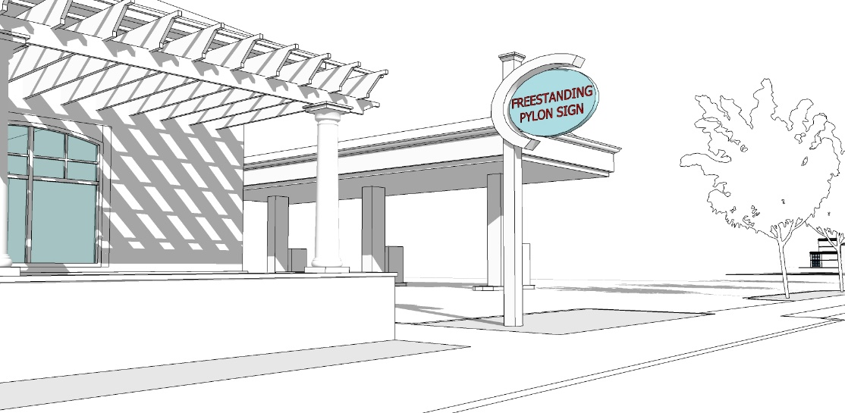
DEFINITION
A sign that is erected or mounted on its own self-supporting permanent structure or base detached from any supporting elements of a building.
ZONING DISTRICTS ALLOWED
See Figure 9.9.2
SIGN SPECIFICATIONS
Number of Signs: | 1 for each street frontage lot maximum
Placement: | When more than 1 freestanding sign is proposed on a site with multiple street frontages, a minimum of 60 linear feet shall separate each sign.
 | No portion of the sign may project into, over or otherwise encroach on a public right of way.
 | Freestanding signs shall be setback a minimum of 10 feet from any interior side lot line; 20 feet from the Street ROW Line; and 50 feet from any residential zoning district.
Sign Height: | Max. 12 feet above grade
Sign Area: | Max. of 40 square feet in the C1 and I districts; Max. of 20 square feet in the C2 by right and 40 square feet by special permit; Max. of 20 square feet in the PD; Max. of 12 square feet in Residential districts.  When only 1 sign is proposed where 2 are permitted, the maximum sign area may be increased by Special Permit and a release of rights to additional freestanding signs for the duration of use of the single larger sign, evidenced by a recordable form of acceptance signed by the property owner.
Illumination: | Non-illuminated or externally illuminated. Down-directed, fully shielded fixtures only.
Landscaping: | Required landscaped area around base of the sign shall be a minimum of 12 square feet consisting of shrubs and/or perennial ground cover plants on permeable ground cover or raised bed with sod and plantings.

D. FREESTANDING SIGNS, Continued
OTHER FUNCTIONAL STANDARDS:
General:
Freestanding signs may be double-sided.
Freestanding signs may not be located in the public R.O.W.
Freestanding signs may by externally illuminated, up-lit, or back-lit.
Electronic Display:
Electronic message or display signs may constitute up 50 percent of the total square feet of a freestanding sign face, incorporated into design of the freestanding signage, and may be double-faced.
Electronic message or display boards must be a continuous stream of light (non-flashing) except that the message may change no more than once per 10 minutes between the hours of 5 AM to 11 PM.
Gas/Service Stations:
Electronic display signs showing gas prices may be incorporated into freestanding signage and may be double-faced.
Gas Pump/Service Island: Canopy sign maximum of 50 square feet for each side of the service island canopy.

Signs shall extend horizontally a max. of 80% of the width of the service island canopy on which it is displayed.
Freestanding and Gas Pump/Service Island signs may be non-illuminated, internally illuminated, or indirectly illuminated.

E. VERTICAL BLADE/BANNER SIGNS
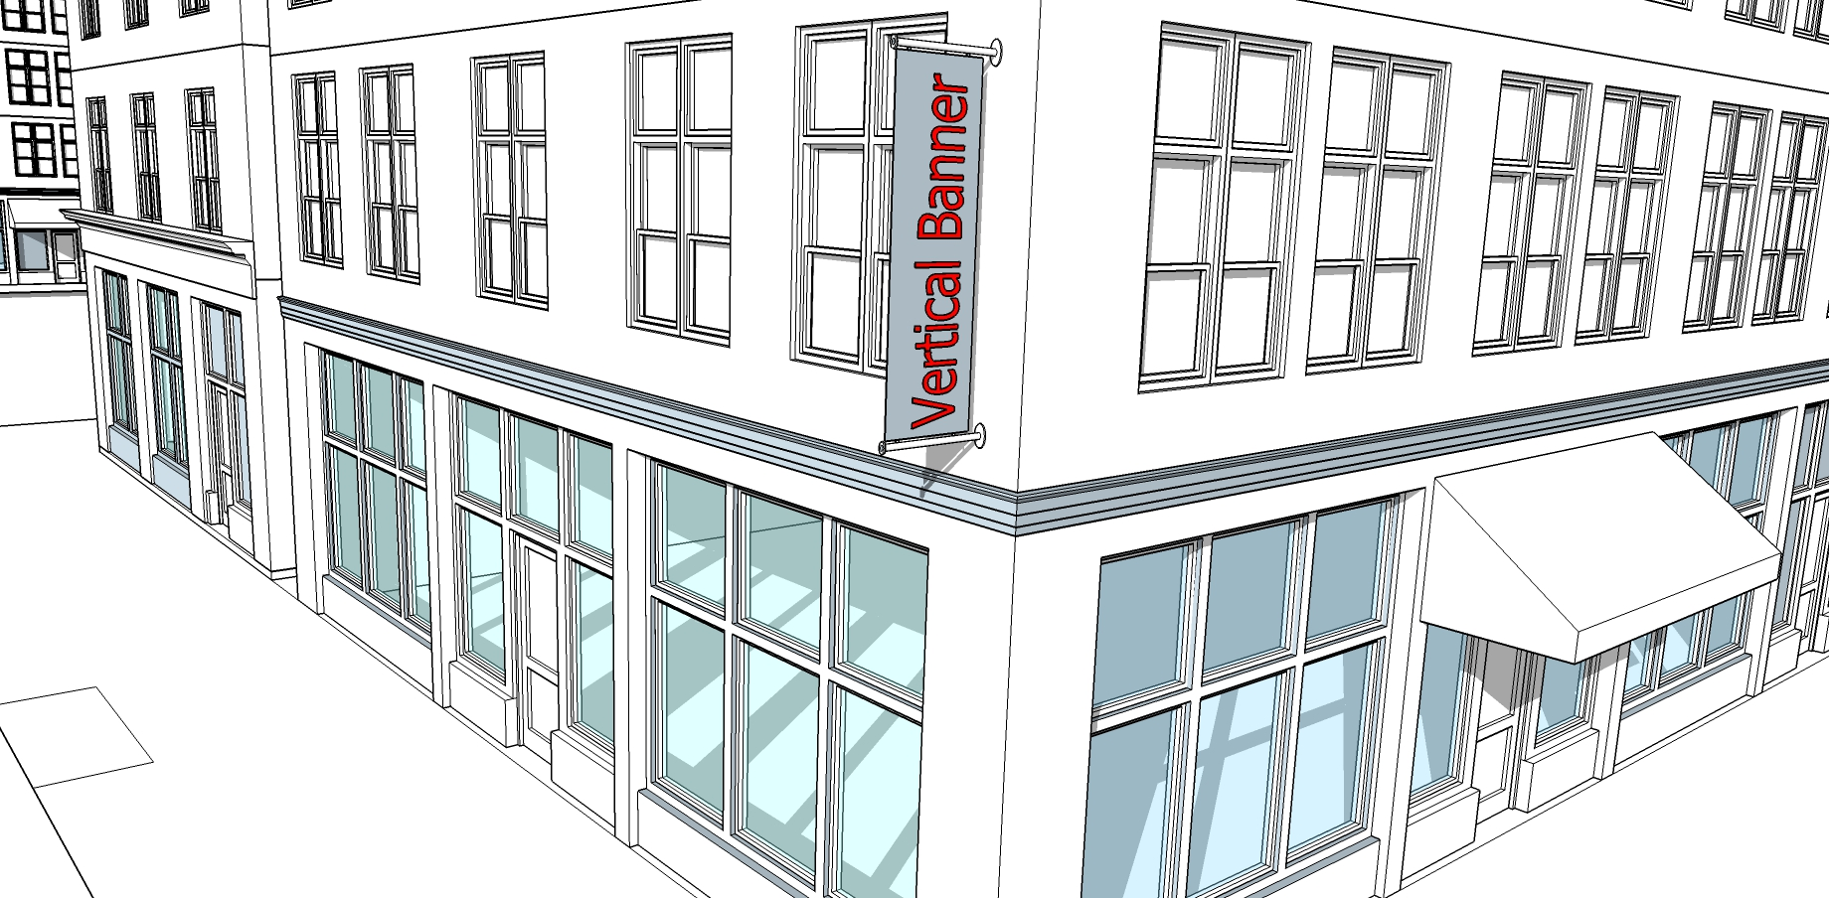
DEFINITION
A tall, narrow, two-sided sign that is attached to and projecting perpendicularly from the I of a building that identifies a
commercial establishment. Vertical blade/ banner signs are intended to be viewed by pedestrians and motorists from a distance.
ZONING DISTRICTS ALLOWED
See Figure 9.9.2
SIGN SPECIFICATIONS
Number of Signs: | 1 sign per 15 feet of façade width; 4 signs max.
Placement: | Signs shall be placed above the first story.
 | Signs may encroach into the public right-of-way but shall not project more than 3 feet from the building.
 | Signs shall be mounted a minimum of 6 inches away from the building.
Sign Height: | 10 feet maximum.
Sign Width: | 4 feet maximum.
Sign Area: | Max. 20 square feet for each business unit.
 | Vertical Banner Signs shall be counted toward total Wall signage area limit for the building.
Sign Lettering: | 75% of sign width maximum.
Illumination: | Non-illuminated or externally illuminated. Down-directed, fully shielded fixtures only.
OTHER FUNCTIONAL STANDARDS
Vertical Blade/Banner signs may be double-sided.
Vertical Blade/Banner signs shall be permitted only for uses on site.
No portion of the sign may project above the roofline of the building to which it is attached.
Information type is limited to business name, logo, and related graphics. Additional information is prohibited.

F. MARQUEE SIGNS
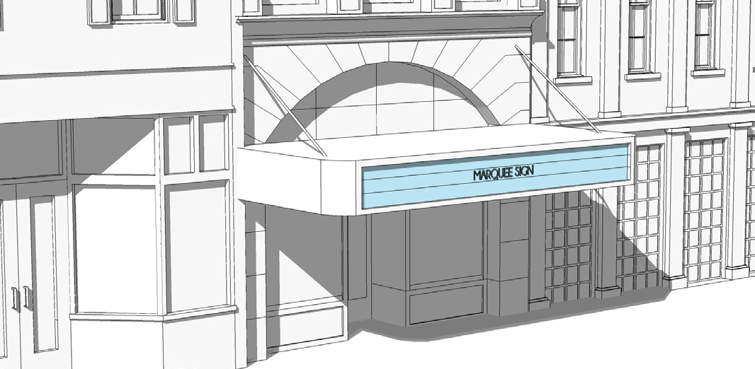
DEFINITION
A sign painted on, attached to, or supported by a marquee—a permanent roof-like shelter, either open or covered, extending from part or all of a building face and constructed of some durable material which may or may not project over a public right-of-way.
ZONING DISTRICTS ALLOWED
See Figure 9.9.2
SIGN SPECIFICATIONS
Number of Signs: | Maximum 1 marquee per building.
Placement: | Primary facades only.
Sign Height: | Min. 10 feet from grade to bottom of the sign.
Sign Area: | Max. 75% of marquee structure’s width and height.
 | Marquees signs shall count toward total signage area limit for the building.
Projection: | 6 feet minimum/10 feet maximum
OTHER FUNCTIONAL STANDARDS
Maximum width of the Marquee shall be the lesser of the width of the building frontage or 40 feet.
Maximum height of the sign is the lesser of 6 feet or 50% of the first story height.
Minimum distance from the curb is 4 feet.
New marquee signs shall be allowed only for theaters, performing arts venues, and sports arenas.
Marquee signs shall be located above the principal entrance of the building.
Marquee signs shall be cantilevered or supported from above. Columns or posts are prohibited.
Changeable message boards with removal physical lettering are permitted by right; Electronic message displays may be permitted by Special Permit.

G. SUSPENDED SIGNS
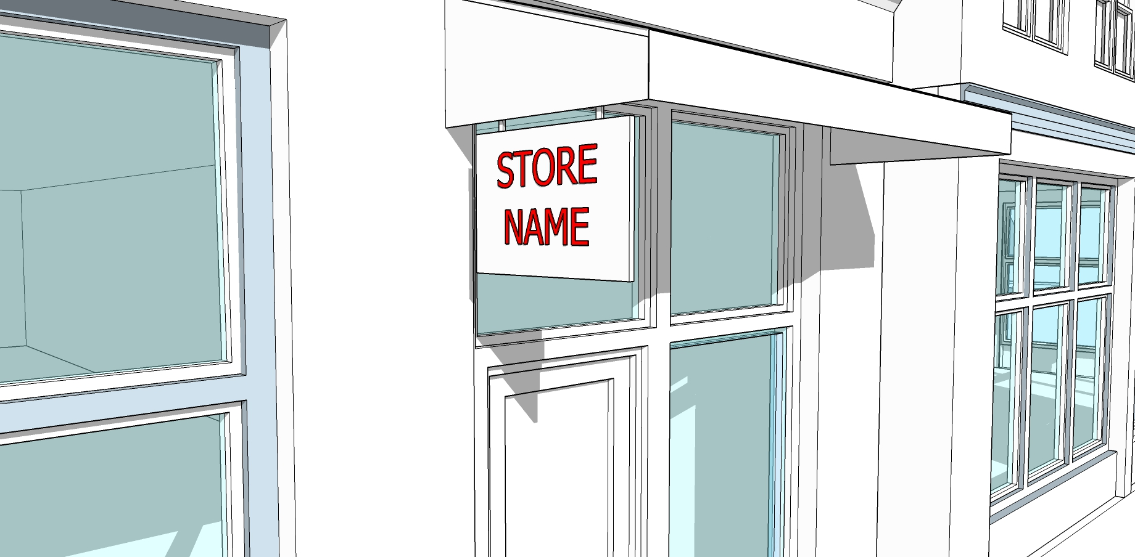
DEFINITION
A small, two-sided sign mounted to the underside of an awning, canopy, or roof of a porch that identifies a commercial establishment. Suspended signs are intended to be viewed by pedestrians at close range on the same side of the street.
ZONING DISTRICTS ALLOWED
See Figure 9.9.2
SIGN SPECIFICATIONS
Number of Signs: | 1 per business unit.
Placement: | A suspended sign may not extend beyond the edge of the awning or canopy it is mounted below.
 | Clear height over the sidewalk shall be 8 feet minimum.
 | Information on the sign must relate to the business.
Sign Height: | 3 feet maximum.
Sign Width: | 3 feet maximum.
Sign Area: | 4 square feet per side maximum.
Illumination: | Non-illuminated or externally illuminated. Down-directed, fully shielded fixtures only.
 | Accent lighting may consist of special lighting strips (non-scrolling or non-flashing LED or neon) to highlight logos or individual letters but does not dominate sign and shall not be considered internal illumination for the purposes of this section.

H. WALL MURALS
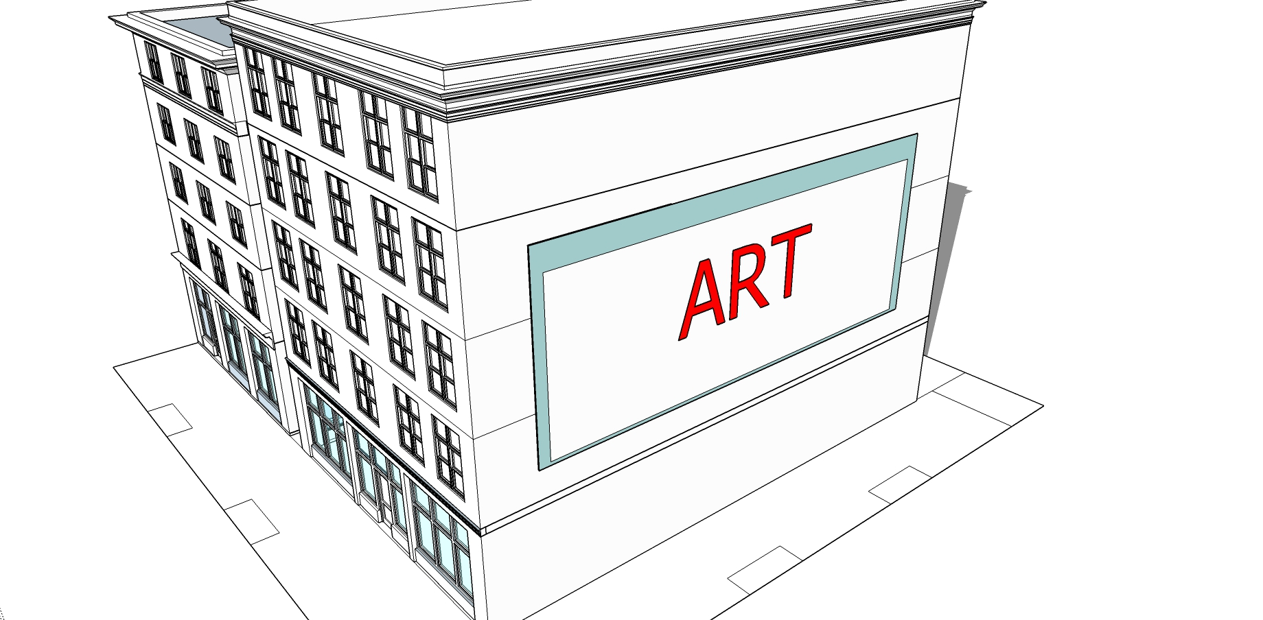
DEFINITION
A sign that is directly painted on or permanently affixed to the exterior wall of a building or screen printed, sewn, or adhered onto a canvas-like material that is mounted flush with the wall of a building that identifies a commercial establishment. Wall murals are intended to be viewed by pedestrians and motor vehicles from a distance.
ZONING DISTRICTS ALLOWED
See Figure 9.9.2
SIGN SPECIFICATIONS
Number of Signs: | 1 per building maximum.
Placement: | On the building façade in a space generally visible to the public.
Sign Area: | 1,000 square feet maximum.
Sign Height: | 50 feet maximum.
Sign Width: | 50 feet maximum.
Height above the Ground: | From ground level to a maximum of the lesser of 2 stories or 30 feet.
Illumination: | Only external illumination is permitted.
OTHER FUNCTIONAL STANDARDS
Lettering or logos must be limited to no more than 20% of the surface area of the wall mural.

Wall Murals requires Special Permit from Planning Board.

I. WINDOW SIGNS
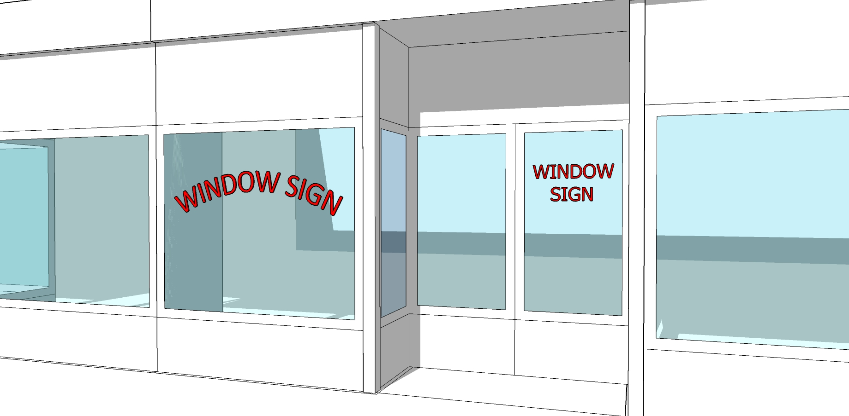
DEFINITION
Any non-illuminated or electronic/electrical static sign (with the exception of neon which shall be permitted as a window sign) which is (a) painted on, applied to, attached to or projected upon the glass area of a building, including doors, whose identification, message, symbol, insignia, visual representation, logo type, or any other form which communicates information is intended to be read from off-premises, contiguous property or a public right-of-way and/or (b) affixed to or within twelve (12) inches of windows of a building, whether temporary or permanent, which may be viewed from the exterior of the building.
ZONING DISTRICTS ALLOWED
See Figure 9.9.2
SIGN SPECIFICATIONS
Number of Signs: | 1 per window and/or 1 per door maximum.
Placement: | 3 feet minimum height from sidewalk to bottom of the sign.
 | See definition above.
Sign Area: | 25% of the window area maximum.
 | Window signs shall not count toward the total signage area limit for the building.
Sign Lettering: | 18 inches maximum lettering height.
Illumination: | Window signs shall not be illuminated however the use of neon is otherwise permitted
OTHER FUNCTIONAL STANDARDS
Characters and logos shall be placed directly on the window or hang no more than 12 inches from the glass.
Items placed more than 12 inches from the glass shall not be considered a sign.
Information type is limited to business name, logo, hours of operations, and product types.
Window signs shall not interfere with the primary function of the window, which is to enable pedestrians and public safety personnel to see through windows into the premises and view product display.

J. MONUMENT SIGNS
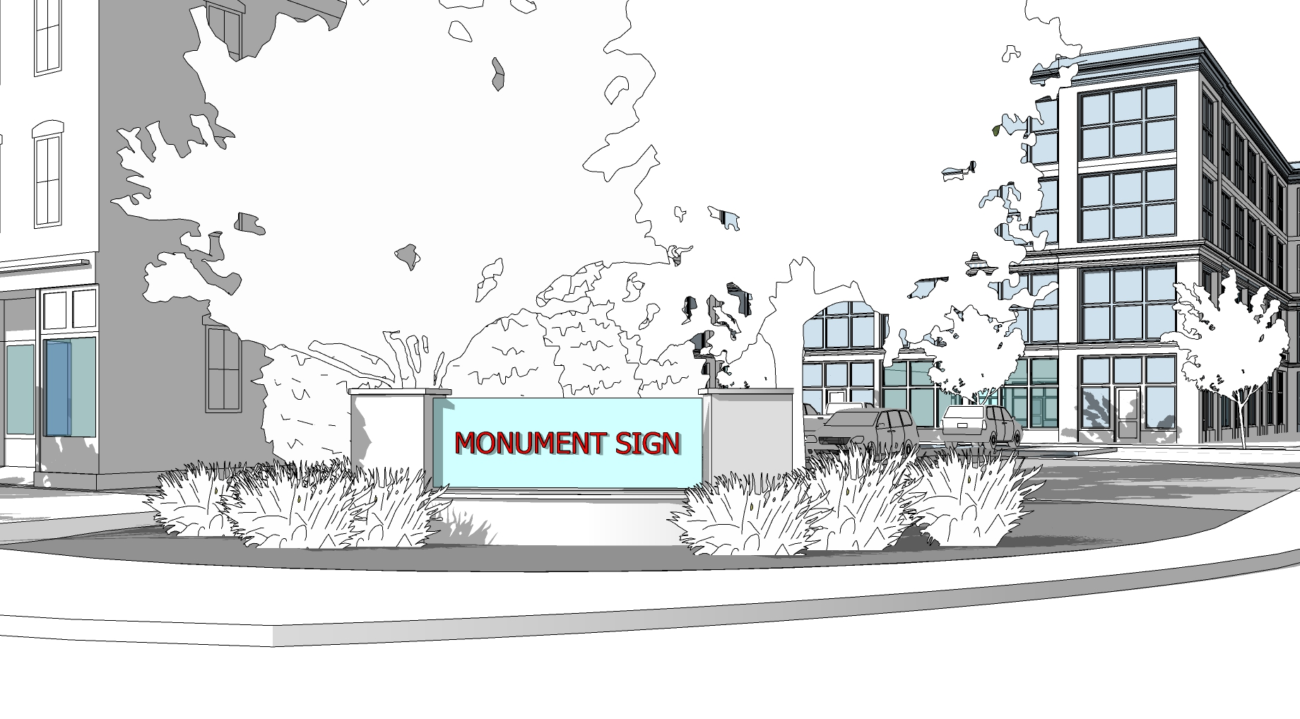
DEFINITION
A freestanding sign having a low profile with no open space between the ground and the sign. The foundational structure shall be constructed of masonry materials. A sign board may be integrated into the foundational structure or on top of the foundation.
ZONING DISTRICTS ALLOWED
See Figure 9.9.2
SIGN SPECIFICATIONS
Number of Signs: | 1 per stand-alone building site, commercial development, or residential development.
Placement: | The front edge of a monument signs may be located five (5) feet from the front and side property line.
Sign Area: | 50 Square Feet Maximum (Per Face).
Sign Foundation Height: | 3 Feet Maximum.
Sign Area Height: | 5 Feet Maximum.
Sign Area Width: | 10 Feet Maximum.
Illumination: | Externally illuminated (on structure or ground)
OTHER FUNCTIONAL STANDARDS
Landscaping: Required landscaped area around base of the sign shall be a minimum of 12 square feet consisting of shrubs and/or perennial ground cover plants on permeable ground cover or raised bed with sod and plantings. A bracket sign must be located at least 25 feet from another bracket sign.
Foundation Materials: Monument sign shall have the appearance of a solid base of landscape construction materials such as brick, stonework, textured wood, tile or textured concrete materials compatible with the materials of the primary structure on the subject property.
Electronic Message Boards: Electronic message or display signs may constitute up 50 percent of the total square feet of a freestanding sign face, incorporated into design of the freestanding signage, and may be double-faced.
Electronic message or display boards must be a continuous stream of light (non-flashing) except that the message may change no more than once per 10 minutes between the hours of 5 AM to 11 PM.

K. WALL SIGNS
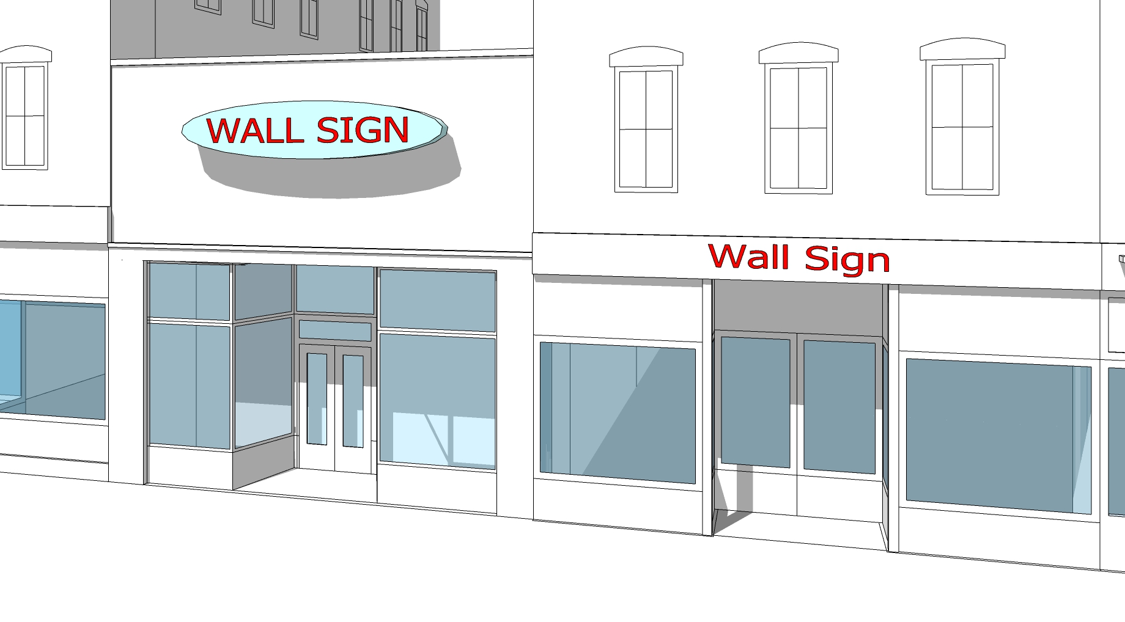
DEFINITION
A sign attached to, painted on, or erected against a wall, parapet, fascia, or a building or structure with the exposed face of the sign in a plane parallel to the vertical face of the building or structure.
ZONING DISTRICTS ALLOWED
See Figure 9.9.2
SIGN SPECIFICATIONS
Number of Signs:
One (1) wall is sign permitted per business frontage on a Primary or Secondary Street.
Placement:
Wall sign shall project a maximum of 15 inches from building wall.
Shall extend horizontally a maximum of 80% of the width of the building wall on which it is displayed.
Sign Area:
Maximum of 1 square feet for each linear foot of primary business façade of each business unit.
If business has frontage on two or more streets, the primary façade contains the primary entrance. Maximum ½ square feet for each linear foot of façade on side with secondary entrances.

OTHER FUNCTIONAL STANDARDS
Overall Dimensions: Each wall sign shall not exceed 50 feet in length, 4 feet in width, and 80 square feet in area.
Sign length maximum of 40 feet and sign width maximum of 3 feet in the PD Zoning District.
Height Above Ground: The top of the sign shall be no more than the lesser of the floor level of the second floor or 25 feet in the PD and DC Zoning District.
Wall signs shall be externally illuminated or backlit in the PD Zoning District.
Neon wall signs are permitted in in the C and PD Zoning District by Special Permit from the Planning Board.

- Temporary and Exempt Signs

- Terminology.
  - Temporary Sign. Portable signs or any signs not permanently embedded in the ground, or not permanently affixed to a building or sign structure, which is embedded in the ground or affixed to a building or sign structure, are considered temporary signs.

- Permitted Temporary Signs by Zoning District.

FIGURE 9.10.1 – PERMITTED TEMPORARY SIGNS
Sign Types | R80 | R40 | R10 | C1 | C2 | I | PD
Temporary Window Signs | A | A | A | A | A | A | A
Real Estate and Construction Signs | A | A | A | A | A | A | A
Special Event Signs | B | B | B | B | B | B | B
Street Banners | N | N | N | N | N | N | N
Projecting Light Signs | N | N | N | C | C | C | C
Portable Message Board Signs | C | C | C | C | C | C | C
Other Temporary Signs | C | C | C | C | C | C | C
A - Permitted by Right with Specifications under this Article
B - Permitted only for approved home occupations, churches, schools, and related institutions intended for public access
C - Permitted by Special Permit. See Special Permit Criteria under Section 9.3.1
N – Not Permitted

- Permitted Temporary Sign Standards. Unless otherwise specified, temporary signs are permitted for a maximum of ninety (90) total days, shall not be illuminated, and do not require a sign permit, but are subject to the following standards:
- Temporary Window Signs. Temporary signs not meeting the requirements for permanent signs may advertise sales, special events, or changes in the nature of an operation and are restricted to devices made of paper, posterboard, cardboard, cloth, canvas, fabric, cardboard, or other light material placed behind display windows, or markings of removable paint or marker inscribed directly on glass, if such devices and markings cover not more than 30% of window area, are not permanently mounted, and are illuminated by building illumination only, but shall not otherwise be used to advertise a continuing or recurrent activity, and shall be removed within seven (7) days after the information they display is out of date or no longer relevant.
- Real Estate and Construction Signs. A temporary sign may be erected during sale, lease, rental, or construction of a building or subdivision. Such sign shall not exceed (40) forty square feet in area for premises in the designated zoning district, and in other cases shall not exceed six (6) square feet in area in residential districts and ten (10) square feet in area in other nonresidential districts. Construction signs shall not be erected prior to the issuance of a building permit, or prior to commencement of work if said work does not require a building permit.
- Special Event Signs. Temporary signs which indicate garage or yard sales, bazaars, dinners, or other nonprofit events and similar occasional uses shall comply with the Winchendon General Ordinances, and any conditions imposed in granting of licenses for such events by the Selectboard.
- Street Banners. A temporary banner or similar sign, if permitted by the Selectboard under its authority to control use of Town ways under General Bylaws may be placed above or across a public or private street or way upon such terms and conditions as the Selectboard shall determine. When a business newly opens, the Building Inspector may as a condition of site plan approval allow the placement of a banner on the premises for a period not to exceed two weeks.
- Portable Message Board Sign. A portable sign not attached permanently to the ground or building designed so that characters, letters, or illustrations can be changed or rearranged without altering the face or the surface of the sign.
- Projected Image Signs. A temporary sign where images are projected on the side of a building or other surface for the purpose of artistic expression, wayfinding, advertiser, or community events notification.
- Other Temporary Signs. To be determined by the Zoning Enforcement Officer.

FIGURE 9.10.1 – ILLUSTRATIVE EXAMPLES OF TEMPORARY SIGNS
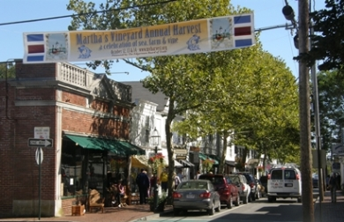 | 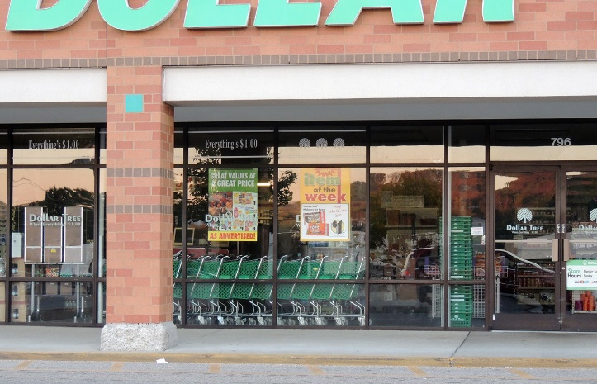
Street Banners | Temporary Window Signs
Special Event Signs | Real Estate and Construction Signs
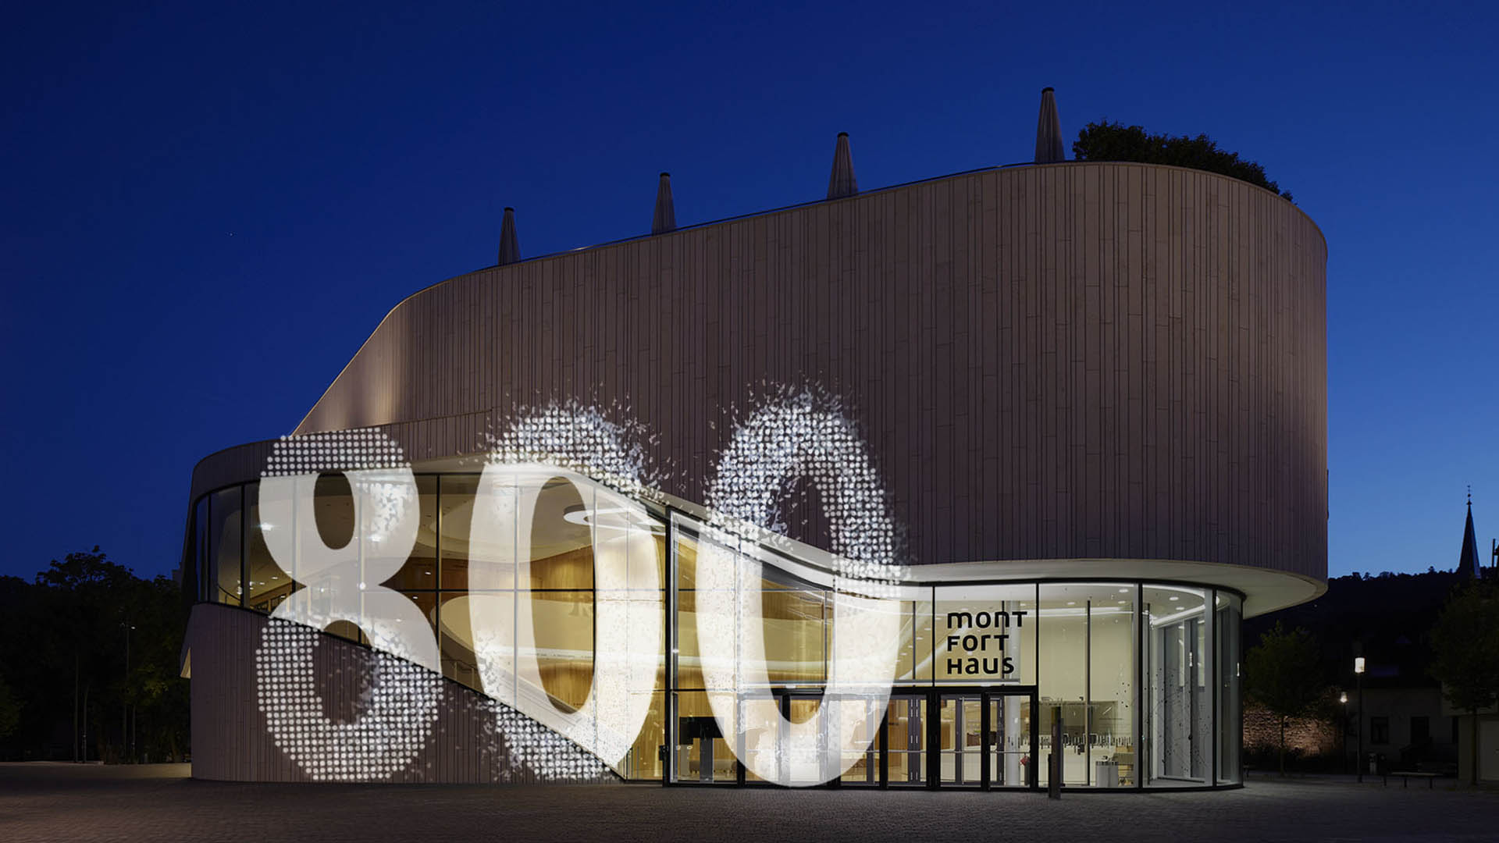
Projected-Image Signs | Portable Message Sign

- Exempt Sign.
- Governmental Signs. Signs, including movable signs, erected, and maintained by the Town of Winchendon, any other municipal corporation, the Commonwealth of Massachusetts, or the Federal Government on any land, building or structure in use by such governmental entity. Any other signs erected by such governmental entity at any location required for public or environmental health, safety, or notification purposes, or announcing the date, time and place of elections or town meetings.
- Prohibited Temporary Signs
Prohibited signs include Balloon Signs & Air-Activated Graphics, Feather Signs (or Teardrop Flag), Advertising Murals, Vehicle Signs, and Billboards.

FIGURE 9.11.1 – ILLUSTRATIVE EXAMPLES OF PROHIBITED SIGNS
 | 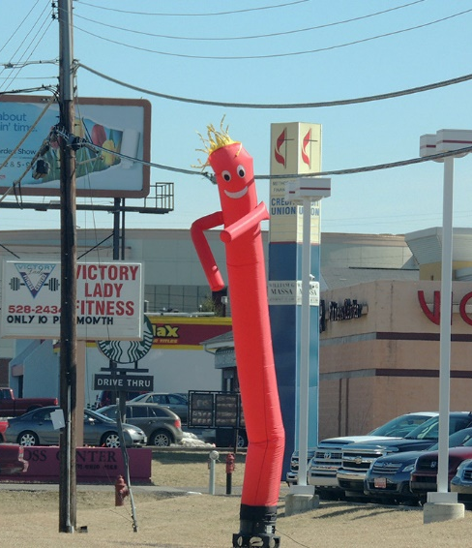
Balloon Signs & Air-Activated Graphics
Vehicle Sign | Advertising Murals
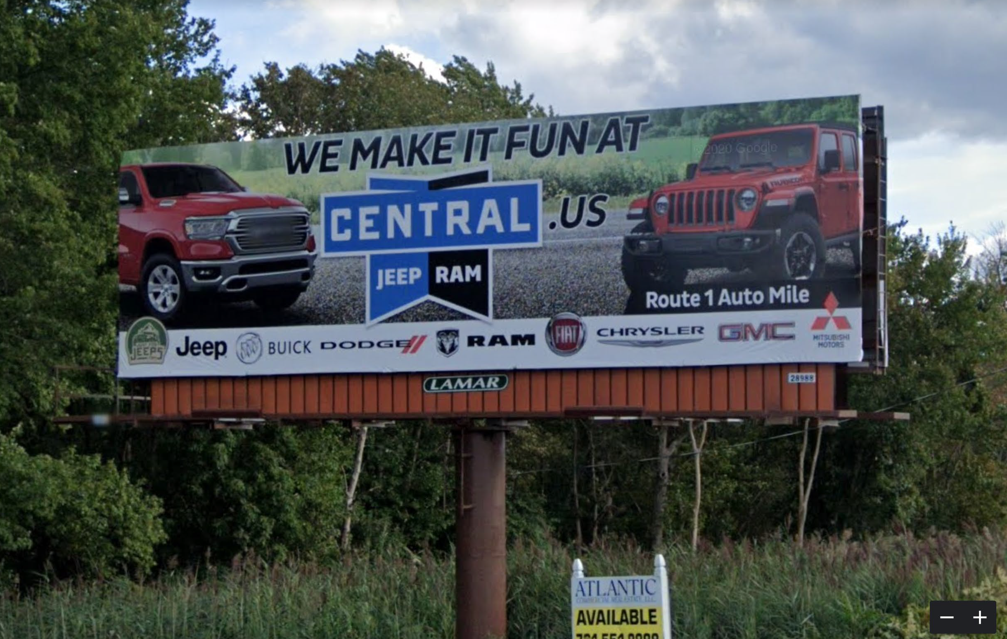
Billboard | Feather Signs/Teardrop Flag

- Planning Board Waiver
The Planning Board may, in its discretion, may waive or modify any of the requirements set forth in this section, if the Board determines that such a waiver does not derogate from the purpose of this bylaw, and is in the public interest.

