tv
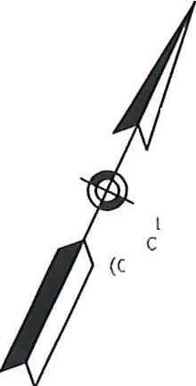
)/Ir
l1t-l n
o::
H

I- '; (·
I B
,n 3
:l.Ioz g5
Z ,,
,

...

LOCATION LINE OF 1965
COUNTY HIGHWAY LAYOUT MK ACQUISITION CORPORATION
(COUNTY LAYOUT H-40D8-R) BK/PG 23D66/30
CERT. 61 3405
PB/PL 582/82
ERVING - GREENFIELD - HATFIELD· MONSON· ;/
ORANGE - SOUTH HADLEY-WARE -WHATELY -
WINCHENDON • ADA RETROFITS ;:

STATE I | FED. NO PROJ. NO. | I5 , r Is |  | T;;s
MA I |  | I | 1 I | 3
 | PROJECT FILE NO. |  | 609469
WINCHENDON

M.H. PARKS CO.
BK/PG 2326/558
30 BROWN ST
MAP/LOT 5C1-0-44 OCATION LINE OF 1965 OUNTY HIGHWAY LAYOUl
OUNTY LAYOUT H-4008-R)
PROP CEM CONG P
PROP LIMIT OF GRADING (
"0 :i
0::: 5
I
ig m_e:.
d ''I'
Cl ---rr
"l'
, 171l••..,,.,J
•:p:.'!--::;,.i

LIMIT OF MILL & OVERLAY

PROP LOAM & SEED
l.C. PLAN NO. 42497A
363 RNER STR[[l,; MAP/LDT7<'.s6

/ APPROXIMATE 100' INNER RIPARIAN ZONE
tv

9D0.96

'j.
'
/
J

l20
MAIN STREET (ROUTE 202) AT BROWN STREET

TC=900.86 BC=900.28
6
0:

i
0
0
i;1,:'i
zu

R&R STREET NAM
----- _;'.R&D EXIS
_;::.. pROP HMA
:::::::: 1l. :::C PROP SEDIM
.. ,.n,,. co
;:::: ;:;::f
-•1;n'llr7J

PROP SEDIMENJltONTROL BARRIER PROP CEM CONG PCR
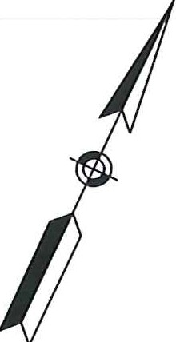
PROP,ifE MP EASEMENT R&D EXIST CB IPED-85514I

900.66
'/1it,..
L13

TC;900.59 BC;900.09

1w-
....
"z'
0u
;:;;
i'

ll.,,._-?.,.

MEET EXIST
,;• 'p) , .,,, -- \ '
ti?
'=-= .:..::..:::., •
------>{ 1.-
PRO U -----+-+-----,,;='t,'--,.,=,,-+l-'-'-1,-lr--'r.,.,-' - ....-f. LIMIT OF WORK
w
0::
Ie-­n
N
J z
/

oz ..,. _ '::• "',.r-.. ,,
·-.
0
:\-, PR
_F>ROPpRSOILPTHSMACAKWA[R
/ L-
i! _{m}

6 .• ,.,,,,..
===--•:

LIMIT OF Ml I - - -_ PROP CBCL BAS[L/N[ '

zw , ;\ '\·
&OVERLAY
-..
_.' / :,, - RIM:'899.0 • _47
; _ _=

Sili
_ ;- •---•· '' INVERT: 894.90- '"''- -
1
I 1.40%

TREET (ROUTE 2o2)\- c::;..-:.!i..' ,,-c • ''cl ;;- -- l :_·- /./"" APPROXIMATE200'
T
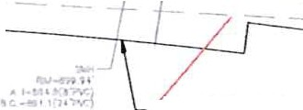
RIVERS ABLEW1DTll·SIIL05330) _ ..._...., OP20 12-'-RCE 7' RIVERFRONTAREA
I .......

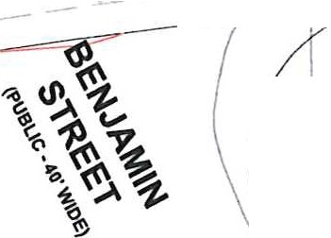
\PUBL1C·VAR1 oL ,,_...., • •" - -
r
\
Anrnu I
/
{ 1--..il

INVERT (PROP
CUT & CAP EXIST 12" RCPJ1amH"'-"'
rot.C '"'
J'.,(( ••j

ROBERT JORDAN /iND 1 1 H•50084(M\t>e-: LISA KLEI.IAN r !
BK/PG 64061/232 :!;.:.,.""'

'LOCATION UNE OF 1963 STAlE HIGHWAY LAYOUT
- SECTION 2
L
/
(LAYOUT No. 5330)

PB/PL 534/50
14 BENJAMIN STREET
MAP/LOT 5D\-0- 71
)"'

MK ACOUISlT!ON CORPORATION
BK/PG 23D66/30 PS/PL 582/82
BENJAMIN STREET /

0 20
50

SCALE: 1"; 20'
100
MAP/LOT 5D1-D-17

521 CMR 22.3.1 WALKWAYS­ CROSSSLOPE
PEDESTRIAN CURB RAMP ON NARROW SIDEWALK WITH DETECTABLE WARNING PANEL {E107.2.1}
PED# | ROADWAY ELEV. AT RAMPt | RAMP REFERENCE POINT |  |  | LENGTH OF PRIMARY RAMP | WIDTH OF SIDEWALK | WIDTH OF RAMP ENTRANCE | DEPTH OF LEVEL LANDING | TRANSITION |  | GUTTER SLOPE
 |  | STREET | STATION | OFFSET |  |  |  |  | LEFT SIDE | RIGHT SIDE
PED-85513 | 899.69 | ROUTE 202 | 48+08 | 23.92' RT |  | 5.0' | 5.8' | 5.5' | 6.5' | 7.8' | 0.60%

()-,

-----------

l
_.../.

/00/

./
c'

899.

TC=899.96

- O.'
PARCEL TABLE
LINE #/CURVE# | LENGTH | DIRECTION/DELTA | RADIUS | TANGENT | NORTHING | EASTING
C1 | 12.00 | 19•ss•,u· | 34.50 | 6.06 | 3071784.26  3071792.92 | 503543.66  503551.88
C2 | 13.88 | 19'52'40" | ,moo | 7.01 | 3071779.86  3071789.88 | 503546.96  503556.47
CJ | 6.47 | 10•44·35· | 34.50 | 3.24 | 3071792.92  3071798.61 | 503551.88  503554.93
C4 | 7.50 | 10'44'35" | 40.00 | 3.76 | 3071789.88  3071796.48 | 503556.47  503560.00
C5 | 5.00 | 8'18'40"· | 34.50 | 2.51 | 3071798.61  3071803.35 | 503554.93  503556.53
C6 | 5.80 | 8"18'40" | 40.00 | 2.91 | 3071796.48  3071601.97 | 503560.00  503561.86
C7 | 7.76 | 12'53'29.. | 34.50 | 3.90 | 3071803.35  3071811.02 | 503556.53  503557.62
C8 | 9.00 | 12•53·29• | 40.00 | 4.52 | 3071801.97  3071810.86 | 503561.86  503563.11
C9 | 15.68 | 26'02'25" | 34.50 | 7.98 | 3071811.02  3071826.25 | 503557.62  503554.54
C10 | 18.18 | 26'02'25. | 40.00 | 9.25 | 3071810.86  3071828.53 | 503563.11  503559.55
l1 | 4.71 | N36'34'32"W |  |  | 3071768.37  3071772.15 | 503531.49  503528.68
l2 | 6.05 | N45"54'23"E |  |  | 3071772.15  3071776.37 | 503528.68  503533.03
L3 | 6.00 | S53"25'28-W |  |  | 3071771.95  3071768.37 | 503536.31  503531.49

PARCEL TABLE
LINE #/CURVE# | LENGTH | DIRECTION/DEL TA | RADIUS | TANGENT | NORTHING | EASTING
L4 | 5.50 | S36°34'32'E |  |  | 3071776.37  3071771.95 | 503533.03  503536.31
L5 | 13.27 | S53'25'28'W |  |  | 3071764.28  3071776.37 | 503543.69  503533.03
L6 | 13.27 | N53'25'28"E |  |  | 3071771.95  3071779.86 | 503536.31  503546.96
L7 | 5.50 | N56'2T1l"W |  |  | 3071789.88  3071792.92 | 503556.47  503551.88
L8 | 5.50 | N67'11'46"W |  |  | 3071796.48  3071798.61 | 503560.00  503554.93
L9 | 5.50 | N75"30'26'W |  |  | 3071801.97  3071603.35 | 503561.86  503556.53
L10 | 5.50 | N88'23"55"W |  |  | 3071810.86  3071811.02 | 503563.11  503557.62
L11 | 16.50 | S24'26'20'E |  |  | 3071641.28  3071826.25 | 503547.71  503554.54
L12 | 16.50 | N24'26'20'W |  |  | 3071828.53  3071643.55 | 503559.55  503552.72
L13 | 5.50 | S65'33'40-W |  |  | 3071643.55  3071841.27 | 503552.72  503547.71
L18 | 6.00 | N24'26'20"W |  |  | 3071641.27  3071846.73 | 503547.71  503545.23
L19 | 6.00 | S24'26'20'E |  |  | 3071649.01  3071643.55 | 503550.24  503552.72
l20 | 5.50 | N65'33'40"E |  |  | 3071846.73  3071849.01 | 503545.23  503550.24

t
t
BC;899.46

i'
!•,

i'

TC=899.58 BC=899.30
L6

TC;899.83 BC;599_33

RIVER STREET (ROUTE 202)

PED-85513

I SCALE:1"=5'
I 10 15 20

SCALE: 1'; 5'
I

8
i 1

i ½
5 £

dli

Slg
!
NOTES:
- 'SLOPE VARIES. VALUE IS MAX SLOPE OF A WARPED PANEL.

- THE PERPENDICULAR DIMENSIONS TO THE CURB ALONG THE SIDEWALK INCLUDE 0.5' FOR THE WIDTH OF THE CURB.

- LENGTHS INDICATED ARE FOR GRADING PURPOSES ONLY. CONTRACTOR SHALL VERIFY CURB LENGTHS IN THE FIELD BASED ON THE DETAILS PROVIDED.

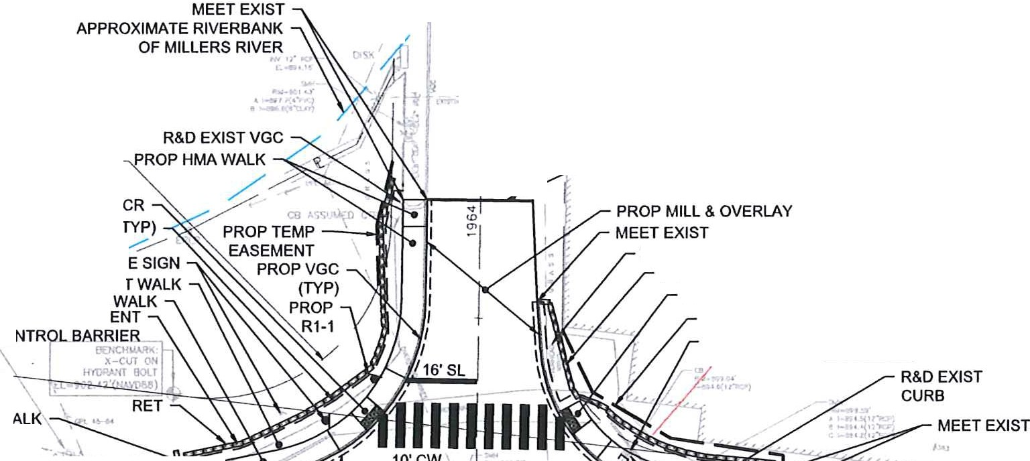
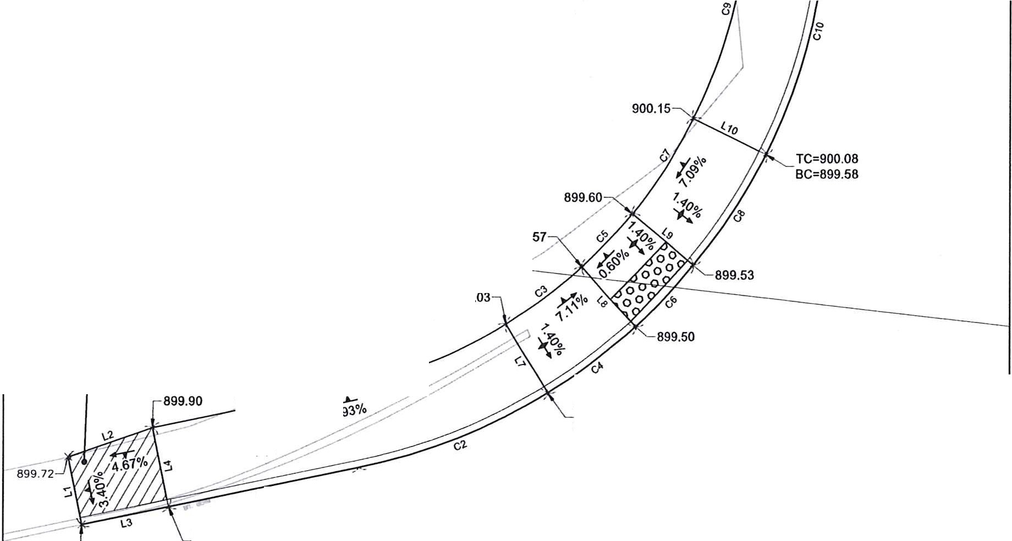
,J

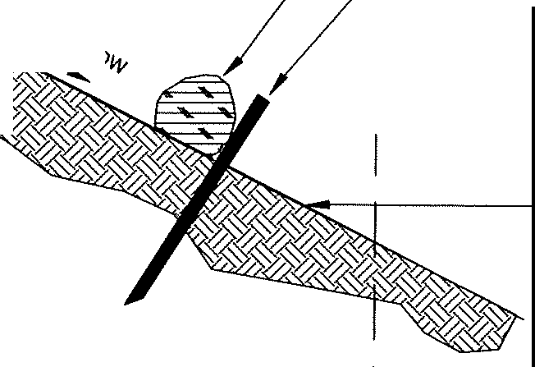
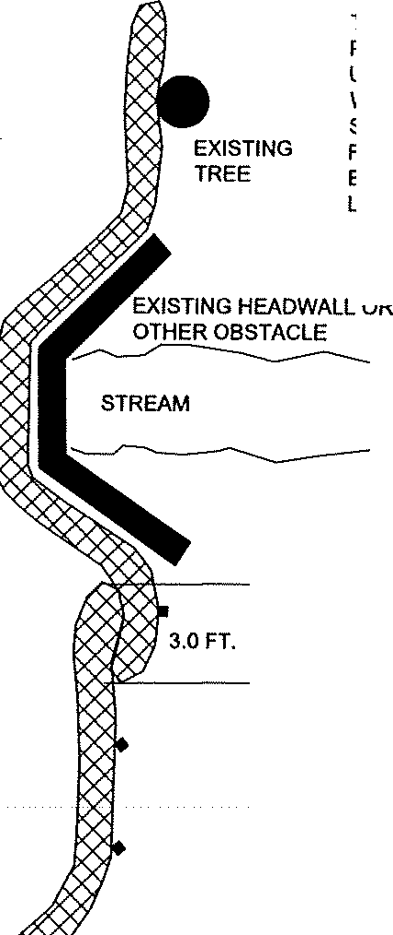
.i.i.'
FINISHED GRADE LOAM BORROW  lf COMPACTED SUBGRADE  DEPTH REFLECTS PLACEMENT AND ROLLING PRIOR TO SEEDING OF LOAM.  LOAM AND SEED DETAILS  Not to SCALE  RETRIEVAL STRAP GEOTEXTILE SKIR \ - 4s•--V--f-3s•  - 7  - ;ASINII"  GEOTEXTILE FABRIC ,TE  SILT SACK NOTTO SCALE |  | DISTRICT2
 |  | ADA RETROFITS AT VARIOUS LOCATIONS
STATE I FED. ND PROJ. 110 I 5 t IsT s
MA I I a I 3
PROJECT FILE NO. 609469
 |  | CONSTRUCTION DETAILS
o,I?.  "f:c,-,  'o,v  - 0,<-""  j |  |  | TUBES CAN BE | TUBES MAYBE PLACED ON THE UPHILL SIDE OF WELL- ANCHORED, STATIONARY FEATURES SUCH AS EXISTING TREES IN LIEU OF STAKING.  i  I0  n.  MIN.  TUBES MAY BE SLEEVED(ONE INSERTED INTO ANOTHER) OR PROVIDE A 3 FT. (914 mm) MINIMUM OVERLAP AT ENDS OF TUBES TO JOIN IN A CONTINUOUS BARRIER.  --- UNTREATED HARDWOOD  STAKES (TYP.)  PLAN VIEW NOTTO SCALE
 |  |  | PLACED DIRECTLY
 | SEDIMENT CONTROL BARRIER  MINIMUM 12 INCHES IN DIAMETER WITH AN EFFECTIVE HEIGHT OF 9.5 INCHES. |  | ON EXISTING  PAVEMENT WHEN NECESSARY.
 | TUBES FOR COMPOST FILTERS SHALL BE JUTE MESH OR APPROVED BIODEGRADABLE MATERIAL, HOWEVER I  PHOTO-BIODEGRADABE FABRIC SHALL BE REMOVED AT END |  | DIRECTION OF FLOW
 | OF CONTRACT.
 | TAMP TUBES IN PLACE TO ENSURE GOOD CONTACT WITH
 | SOIL SURFACE. IT IS NOT NECESSARY TO TRENCH TUBES
 | INTO EXISTING GRADE. |  | w  u. () |  | GENERAL NOTES:  1. PROVIDE A MINIMUM TUBE DIAMETER OF
 | ,,....... COMPOST TUBES SHALL BE STAKED OR LEANED AGAINST |  | 0  .ii |  | 12 INCHES FOR SLOPES UP TO 50 FEET IN  LENGTH WITH A SLOPE RATIO OF 3H:1V OR STEEPER. LONGER SLOPES OF 3H:1V
 | SUPPORTS (TREES, CINDER BLOCKS) ON SLOPES 2:1 OR  GREATER. |  | iS |  | MAY REQUIRE LARGER TUBE DIAMETER  OR ADDITIONAL COURSING OF FILTER
 |  |  |  |  | TUBES TO CREATE A FILTER BERM.
 | WHERE NECESSARY, STAKING SHALL BE MIN. 1 INCH X 1 INCH  X 3 FEET UNTREATED HARDWOOD STAKES, UP TO 5 FT. APAR |  |  |  | REFER TO MANUFACTURER'S  RECOMMENDATIONS FOR SITUATIONS
 | OR AS REQUIRED TO SECURE TUBES IN PLACE. TUBES SHALL |  |  |  | WITH LONGER OR STEEPER SLOPES.
 | BE STAKED ACCORDING TO MANUFACTURER'S |  |  |  | 2. INSTALL TUBES ALONG CONTOURS AND
 | SPECIFICATIONS.  UNDISTURBED SOIL & VEGETATION.  TUBES SHALL BE PLACED AS CLOSE TO LIMITS OF SOIL DISTURBANCE AS POSSIBLE. |  | DIRECTION OF FLOW |  | PERPENDICULAR TO SHEET OR  CONCENTRATED FLOW.  3. TUBE LOCATION MAY BE SHIFTED TO ADJUST TO LANDSCAPE FEATURES, BUT SHALL PROTECT UNDISTURBED AREA
 |  |  |  |  | AND VEGETATION TO MAXIMUM EXTENT
 | LIMIT OF WORK |  | CURVE ENDS UPHILL TO PREVENT DIVERSION OF UNFILTERED  RUN-OFF. |  | POSSIBLE.  - DO NOT INSTALL IN PERENNIAL, EPHEMERAL OR INTERMITTENT STREAMS.  - ADDITIONAL TUBES SHALL BE USED AT THE DIRECTION OF THE ENGINEER.  - ADDITIONAL STAKING SHALL BE USED AT
 |  |  |  |  | THE DIRECTION OF THE ENGINEER.
 | SEDIMENT CONTROL BARRIER
 | NOTTO SCALE

z
J
I
u

0

t;;

z
0
§
.:,,: ,
I

